

**LA GRANDEE INTERNATIONAL COLLEGE**

**Simalchaur, Pokhara Nepal** Project Proposal Report On **“Freelancing Platform”**

**Submitted to:**

Bachelor of Computer Application (BCA) Program

In partial fulfilment of the requirements for the degree of BCA under Pokhara University

**Submitted by:**

**Name: Course Semester P.U. Registration Number**

Anish Baniya BCA 6th 2021-1-53-0352

Sabin Gurung

BCA 6th 2021-1-53-0353

Suyan Thapa BCA 6th 2021-1-53-0371

**Date: 30/09/2024**

Table of Contents

Table of Figures iii

Abbreviations iv

1. Introduction 1
2. Background Study 2
3. Problem Statement 3
4. Objectives 4
5. Methodology 5
6. Project Gantt chart 6
7. Deliverables 7
8. Reference 8

# Table of Figures

Figure 5.1: Agile Model 5

Figure 6.1: Project Gantt Chart 6

# Abbreviations

|  |  |
| --- | --- |
| CSS | Cascading Style Sheet |
| ER-Diagram | Entity Relational Diagram |
| GMS | Gym Management System |
| HTML | Hypertext Markup Language |
| MS Office | Microsoft Office |
| MS Word | Microsoft Word |
| MySQL | My Structured Query Language |
| PHP | Hypertext Preprocessor |
| RDBMS | Relational Database Management System |
| VB.NET | Visual Basic Network Enabled Technologies |

# Introduction

Introduction Part

# Background Study

Background study part

# Problem Statement

* + P1
  + P2

# Objectives

* + O1
  + O2
  + 03

# Methodology

A methodology is a series of processes or phases, which helps you define which stage you are at the given period. A set of procedures or methods to develop software is known as software development methodology. Methodology shapes a structure of software thus it is important to precisely choose the required method to develop software. In Context of our project, we choose Waterfall Module to develop a project as it works well in small project. In this method, project activities are break into linear sequential phases, each phase depends upon the previous one.

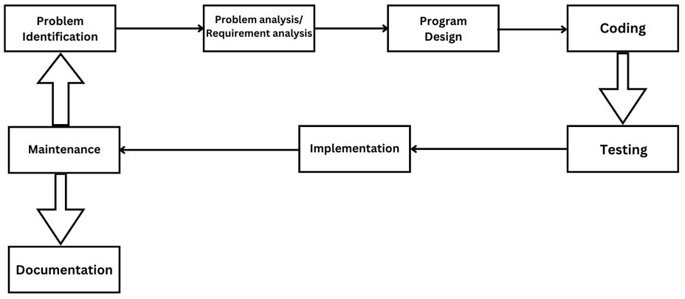

Figure 5.1: Agile Model

# Project Gantt chart

A Gantt chart is a popular project management tool used to visualize the schedule of a project. It displays tasks or activities against time, allowing project managers to track progress, manage dependencies, and allocate resources efficiently.

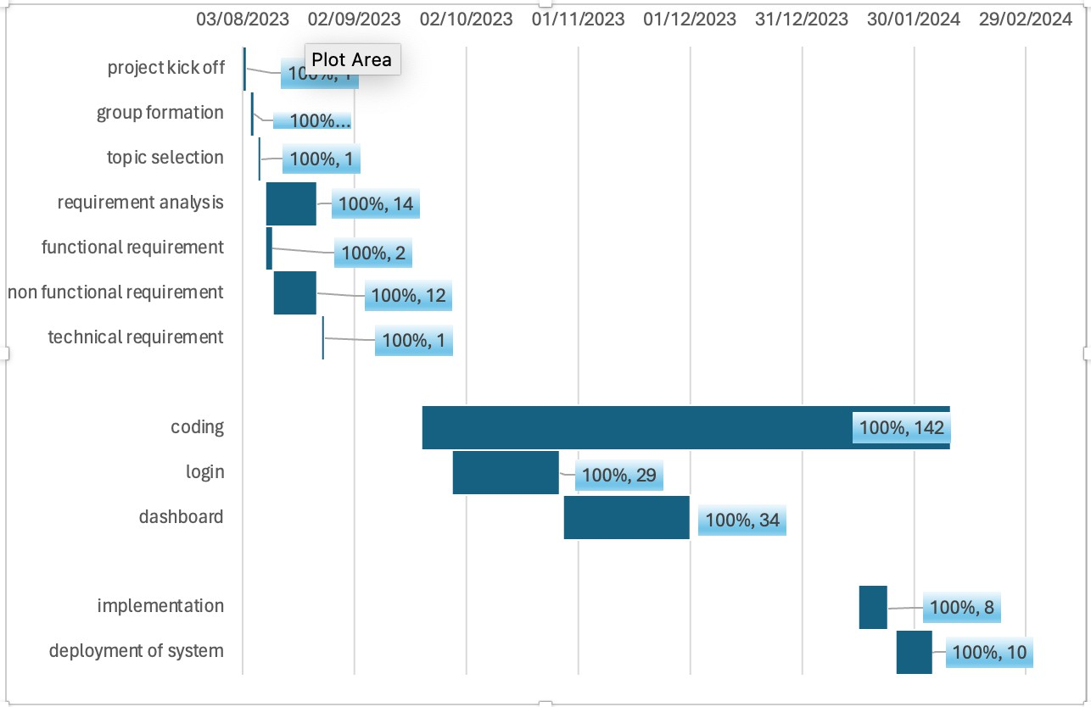

Figure 6.1: Project Gantt Chart

# Deliverables

* + **D1**: D1-description
  + **D2**: D2-description
  + **D3**: D3-description

# Reference Bibliography

xyz